REPORT

**BATTLE OF THE NEIGHBOURHOODS**

*New York vs Toronto*

Data Science Professional Certificate Capstone Project

Contents

**1.0 Introduction 2**

**2.0 Data 2**

**3.0 Methodology 3**

**4.0 Results 3**

**New York 3**

**Map of all available Restaurants 3**

**Map of all available Tourists Sites 3**

**Toronto 4**

**Map of all available restaurants 4**

**Map of all available Tourist Sites 4**

**5.0 Summary 4**

**6.0 Conclusion 5**

**BATTLE OF THE NEIGHBORHOODS ASSIGNMENT**

# **1.0 Introduction**

With a large number of people who want to travel and visit places abroad, but with limited funds, it's imperative that they to gain useful data and analysis to aid them pick the best location to visit, according to their preferences.

Most travelers in Africa like to tour America at least once in their lifetime, however, new information circulating here is that Canada is also a great destination for tour.

The purpose of this project is to compare/contrast various services individually found in these two countries, focusing on two financial cities within them. i.e., New York- America, Toronto- Canada. Services that will be compared will be things like restaurants, and the number of tourist sites.

# **2.0 Data**

Information and analysis will be gained directly from Foursquare. Exact Latitudes and Longitudes will be gained from prior work done; information gained there was from a Wikipedia site with latitudes and longitudes. The data will be analyzed by providing analysis on the individual areas and then providing a final summary based on the results.

# **3.0 Methodology**

I used Pandas and NumPy libraries mainly for the analysis. Also, folium was using in aiding visualization the areas in the form of maps.

The two areas are analyzed separately and then compared using the tables and maps, mainly. Maps were used in the analyzing process because they are easy to observe and interpret.

# **4.0 Results**

Results gained from the data analysis were as follows:

## New York

### Map of all available Restaurants

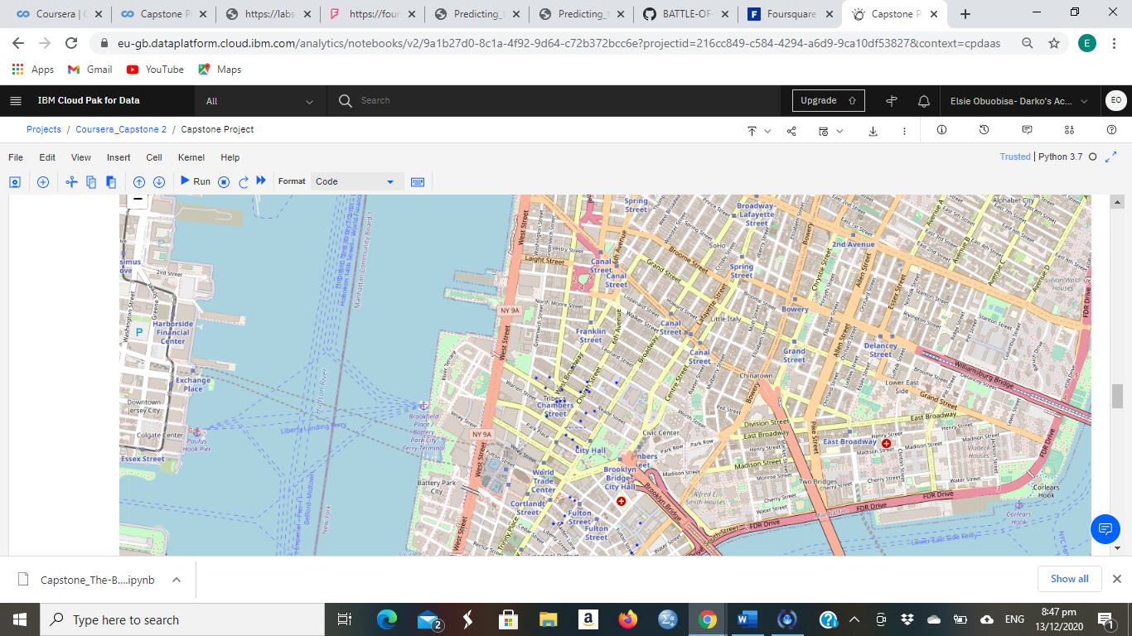

### Map of all available Tourists Sites

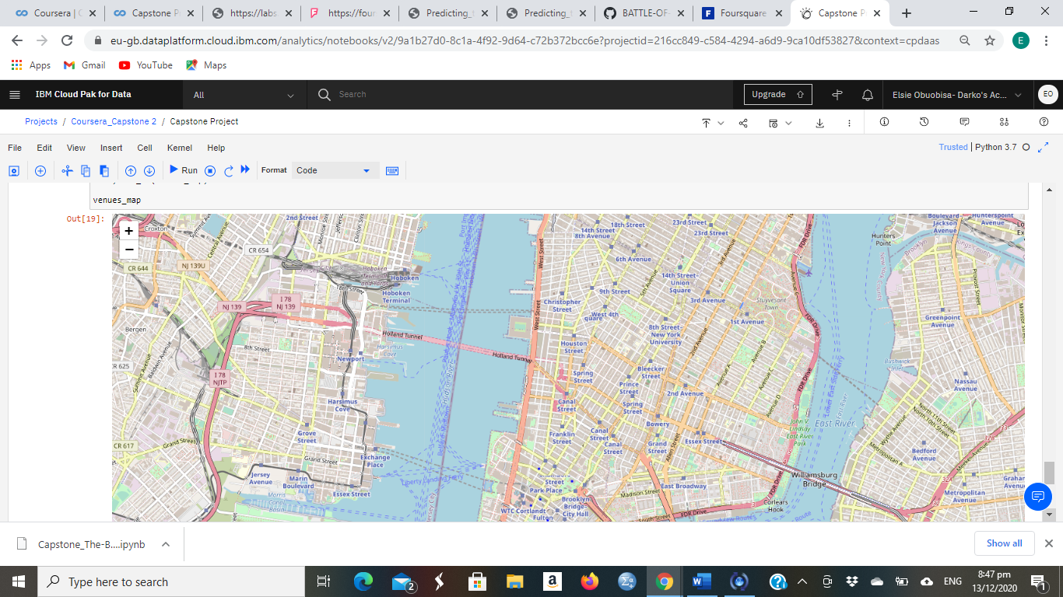

## Toronto

### Map of all available restaurants

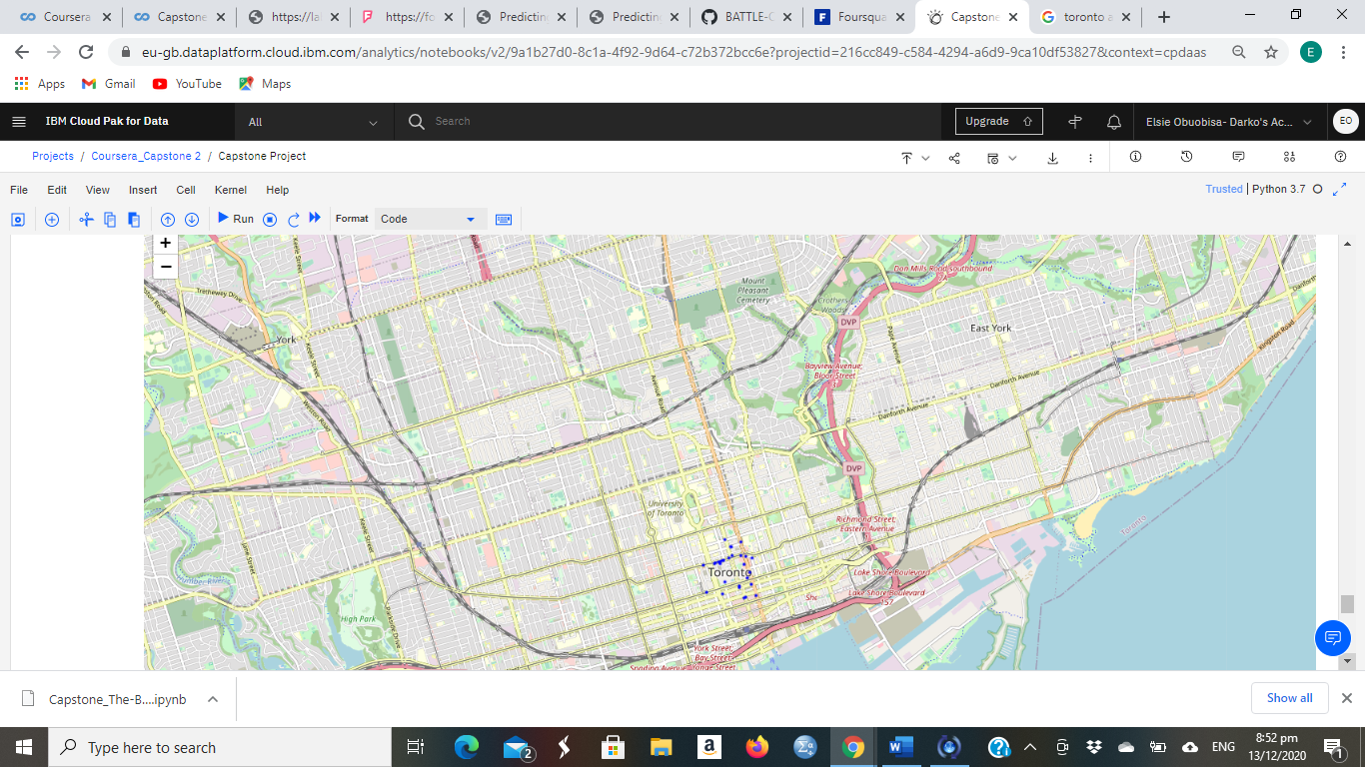

### Map of all available Tourist Sites

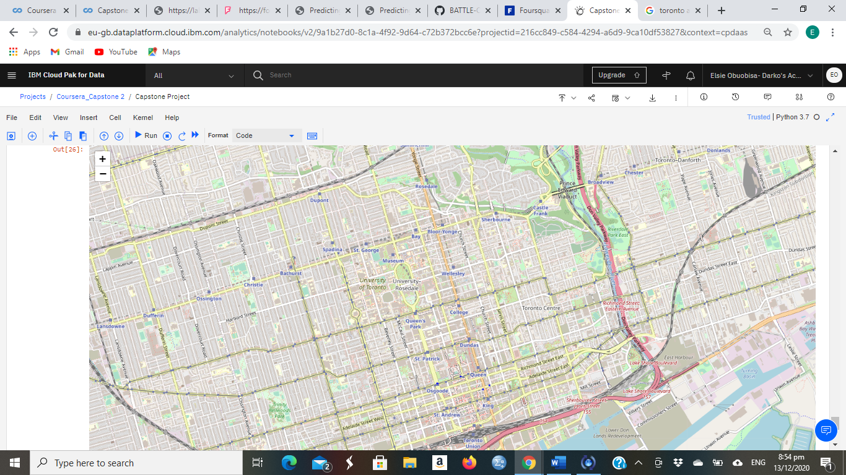

# **5.0 Summary**

After the data analysis procedures performed in Jupyter Notebook, the maps above were generated. From careful observation of the map and panda dataframes, it can be observed that:

* Toronto had a larger number of restaurants than New York.
* New York on the other hand had a significant amount of tourist sites than Toronto.

# **6.0 Conclusion**

In this report, I examined two different locations to gain certain information that would help guide a new traveler determine which city to visit. The two guides I used to perform data analysis were tourist sites and restaurants. This is because these are the two main reasons people travel and move from one location to another.

Per the results gained, we can deduce or gather that if a traveler prefers to explore more restaurants and food vendors than tour; Toronto is the better option, however if site seeing and tourist is the paramount reason an individual is motivated to travel by, New York would be a better option due to the larger amount of tourist sites there.